WinCE 6.0 Device Adding and Canceling Prefix and Suffix

1, 2D Scan engine

  - PDA Tools-->Barcode 2D-->ScannerSet-->Press key F1, and input related prefix and suffix, please note click relevant icon ‘Set’ to save configuration(as figure 1-5), then it will pop up the prompt message ‘Settings Succeed’ means add prefix and suffix successfully.

1.2 Canceling Prefix and Suffix: Related operation similar with adding prefix and suffix, PDA Tools-->Barcode 2D-->ScannerSet-->Press key F1, and delete related prefix and suffix, please note click relevant icon ‘Set’ to save configuration, then it will pop up the prompt message ‘Settings Succeed’ means cancel prefix and suffix successfully.

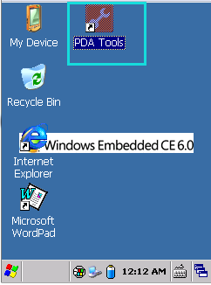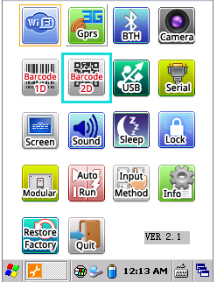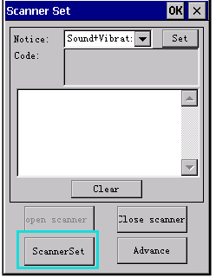
Figure 1-1 Figure 1-2 Figure 1-3

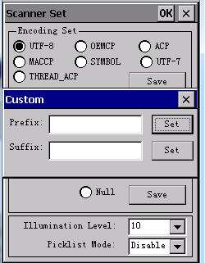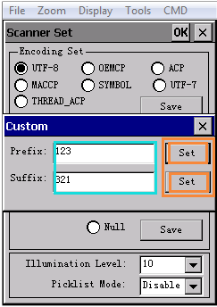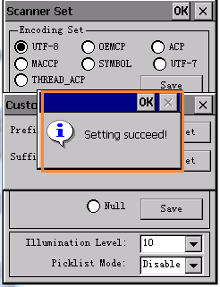
Figure 1-4 Figure 1-5 Figure 1-6

2, 1D Scan engine

2.1PDA Tools-->Barcode 1D-->Advance-->Press key F1, and input related prefix and suffix, please note click relevant icon ‘Set’ to save configuration(as figure 2-5), then it will pop up the prompt message ‘Settings Succeed’ means add prefix and suffix successfully.

2.2 Canceling Prefix and Suffix: Related operation similar with adding prefix and suffix, PDA Tools-->Advance-->ScannerSet-->Press key F1, and delete related prefix and suffix, please note click relevant icon ‘Set’ to save configuration, then it will pop up the prompt message ‘Settings Succeed’ means cancel prefix and suffix successfully.

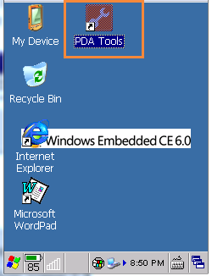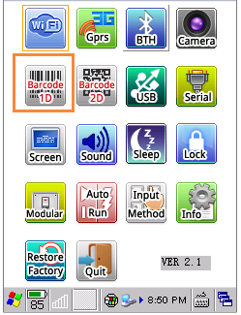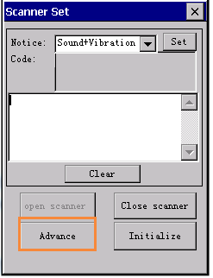
Figure 2-1 Figure 2-2 Figure 2-3

